# KUALA SELANGOR KOLEJ VOCATIONAL COLLEGE

**2024**

*E-Ordering System*

The E-Ordering System Revolutionizing Education at Kuala Selangor Vocational College

Kuala Selangor Vocational College

## ABSTRACT

In the realm of education, the infusion of technology is reshaping traditional practices, aiming to enhance efficiency and organization. A notable example of this transformative shift is witnessed in the Bakery and Pastry Program at Kuala Selangor Vocational College; also known as Kolej Vokasional Kuala Selangor (KVKS), where a pioneering approach has been adopted to address the challenges of order management and data accuracy. The e-Ordering System, an innovative solution, was introduced not merely to expedite processes but also as a conscious effort to reduce environmental impact by substituting paper-intensive methods with digital alternatives. This integration goes beyond the mere utilization of technology; it signifies a significant evolution in educational practices. The e-Ordering System, functioning as more than just a tool, symbolizes the harmonious synergy between education and technology. Its role is to simplify complexities, providing an enriched learning experience for all involved in the Bakery and Pastry Program. Thorough testing has been conducted to ensure the system's functionality, assuring its seamless operation. This transformative change isn't just about using computers; it represents a fundamental shift in the educational paradigm. It's not only about convenience but also a thoughtful consideration of its environmental impact. The e-Ordering System serves as a beacon, demonstrating how education and technology can collaborate to streamline tasks and improve the overall learning experience for everyone associated with the Bakery and Pastry Program.

**Key Words:** Kolej Vokasional Kuala Selangor (KVKS); e-ordering system, Bakery and Pastry

## INTRODUCTION

In the heart of the Bakery and Pastry Program at Kolej Vokasional Kuala Selangor; also known as Kuala Selangor Vocational College (KVKS), a pioneering paradigm shift unfolds as technology takes center stage to revolutionize the handling of orders and ensure data accuracy. In an era where traditional methods face the need for efficiency and environmental consciousness, this thesis explores the transformative impact of the newly introduced E-Ordering System. By substituting paper-intensive methods with digital alternatives, this innovative approach not only streamlines processes but also stands as a testament to the harmonious synergy between education and technology. The traditional landscape of order management within the Bakery and Pastry Program has long grappled with challenges related to manual processes and data inaccuracies. This prompts us to ask if Education 4.0 will require a fundamental transformation in our approach to the design and delivery of teaching and learning, and the provision of smarter learning spaces, services and learning tools? Further, how, in this period of disruption, can Higher Education institutions plan to educate for the future? (Daanen & Facer, 2007, p. 3). Recognizing the need for a streamlined and environmentally sustainable solution, the integration of the E- Ordering System is a timely response to the evolving demands of modern education. This transformative change is not just about adopting a new tool; it symbolizes the harmonious synergy between education and technology. The E-Ordering System is designed to enrich the learning experience for all stakeholders involved in the Bakery and Pastry Program, fostering a collaborative environment that embraces the benefits of technological advancements. At its core, the integration of the E-Ordering System is driven by a commitment to providing an enriched learning experience. Beyond the practicalities of order management, the system is poised to positively impact the educational journey of both students and educators, setting a precedent for the integration of technology in vocational education. In the implementation of changes in TVET systems and policies, the quality of TVET organizational leadership has been at a moderate level. The impact of this moderate quality of TVET leadership has contributed to issues and challenges in the implementation of TVET education changes at College Vocational (Mat Nashir and Mustapha, 2017).

## LITERATURE REVIEW

### Technical and Vocational Education (TVET)

The vocational field provides opportunities for students with good or moderate academic achievements who are interested in vocational learning related to employment. The content of the vocational field has a balanced combination of theoretical and practical components. The objective of this stream is to help produce semi-professionals (technicians/technical assistants) in engineering and non-engineering fields. Upon completion of studies, students can pursue further education in public or private higher education institutions, public and private skills training institutes, or enter the workforce directly (KPM, 2019). The integration of technology in educational institutions has been a subject of extensive research.

### Bakery and Pastry Program

This program offers students related to the production and preparation of bread, cakes, pastries, chocolates, desserts, donuts, buns, pizzas, creating and developing new and special recipes, as well as cost management and business in this field.

### Ordering System

An ordering system is a structured process or set of procedures designed to facilitate the purchase or acquisition of goods or services. It plays a crucial role in streamlining the transactional aspects of various industries, including retail, e-commerce, hospitality, and more. The development of interactive technologies has led to customers being more active and engaged in different commercial activities, such as gathering information, comparing alternatives, purchasing, and providing reviews (Alalwan, 2020, pp. 28-44).

### Waterfall Model

The waterfall model is the classical model of software engineering. It is referred as a linear- sequential life cycle model. In a waterfall model, each phase must be completed before the next phase can begin. The waterfall model serves as a baseline for many other lifecycle models. The waterfall model phase begins with communication, planning, modelling, construction, and finally deployment phase (Xin & Abd Ishak, 2023, pp. 524–543)

## METHODOLOGY

This research focuses on developing the ADDIE model using task learning approaches. A purposeful sample of twelve (12) lecturers from the Bakery and Pastry Program at Kuala Selangor Vocational College was selected due to study limitations. Data collection employed three types of validated needs analysis questionnaires to assess system operations and user-friendliness in the program.

## RESULT AND DISCUSSION

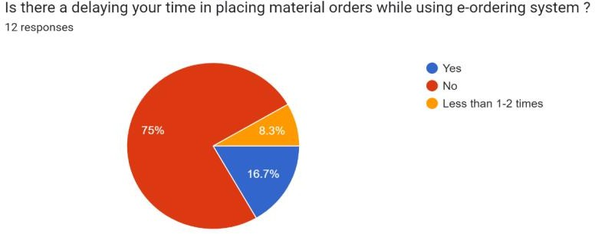

Figure 1: Delaying time placing material order

Based on this Figure 1, 75% of lecturers agree that there is no delay in placing orders within the system, only 16.7% experience such delays, and 8.3% have encountered them 1-2 times.

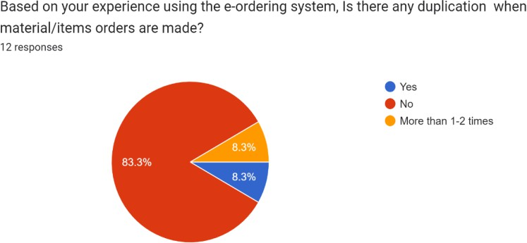

Figure 2: Experience using the e-Ordering System

Based on the feedback on Figure 2, the pie chart indicates that 83.3% of lecturers can place material orders without any overlap. Only 8.3%, corresponding to one lecturer, reported experiencing order overlap, while another 8.3% of lecturers encountered it 1-2 times while using the system.

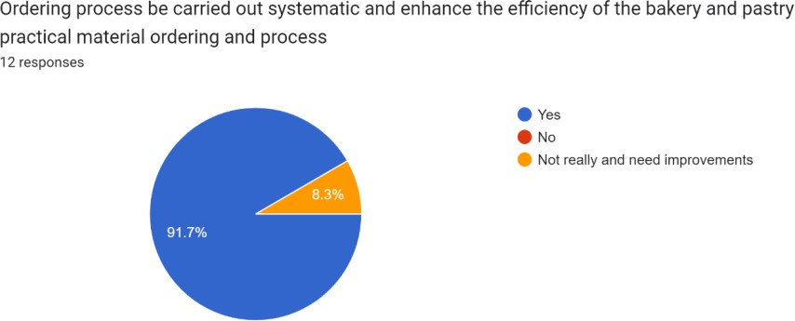

Figure 3: Feedback the efficiency of e-Ordering System

Based on Figure 3, 91.7% of lecturers agree that this system can meet the needs of practical classes and enhance the functionality of the digital system for teaching and learning at Kuala Selangor Vocational College. Only 8.3% hold a contrary opinion.

## CONCLUSION AND RECOMMENDATION

As a conclusion to the project, the e-Ordering System was successfully developed, providing an efficient solution for ingredient procurement in the Bakery and Pastry program. The main objective of this E-Ordering System was to relieve the burden on lecturers for efficient ingredient procurement. The findings highlighted that most lecturers agree that there is no delay in placing orders within the system. In addition, lecturers can place material orders without any overlap while using the system. 91.7% of lecturers agree that this system can meet the needs of practical classes and enhance the functionality of the digital system for teaching and learning at Kuala Selangor Vocational College. One limitation of the E-Ordering System is that it requires an internet connection to use the application. Finally, Technology transforms processes for efficiency in the Bakery and Pastry Program at Kuala Selangor Vocational College. The E-Ordering System ensures convenient, paperless orders and representing a significant evolution in educational practices.

## REFERENCES

Alalwan, Ali Abdallah (2020). *Mobile food ordering apps: An empirical study of the factors affecting customer e-satisfaction and continued intention to reuse*. International Journal of Information Management, 28-44. Retrieved from https://doi.org/10.1016/j.ijinfomgt.2019.04.008.

Daanen, H. & Facer, K (2007). *2020 and beyond: Future scenarios for education in the age of new technologies.* Futurelab. Retrieved from <http://archive.futurelab.org.uk/resources/publications-reports-articles/opening-education-> reports/Opening-Education-Report663.

KPM (2019). *Penerangan Bidang.* Kementerian Pendidikan Malaysia. Retrieved from https://[www.moe.gov.my/pendidikan/tvet/kolej-vokasional/penerangan-bidang.](http://www.moe.gov.my/pendidikan/tvet/kolej-vokasional/penerangan-bidang)

Mat Nashir, Irdayanti & Mustapha, Ramlee. (2017). *A new TVET leadership model: Combination of innovative and instructional paradigms*. Journal of Asian Vocational Education and Training 10(1), 1–16. Retrieved from https://[www.researchgate.net/publication/341814685.](http://www.researchgate.net/publication/341814685)

Xin, Loo Zhi & Abd Ishak, Suhaimi (2023). *Design and Development of Web-Based Foodbank Management System by Using Waterfall Approach*. Applied Information Technology and Computer Science. 524–543. Retrieved from https://publisher.uthm.edu.my/periodicals/index.php/aitcs/article/view/7452.